**西南大学计算机与信息科学学院**

**《C++》之**

**实验004： 师徒关系**

**实验基本信息：**

未命名实验类型： □验证性 □设计性 □综合性

理论教师： 代立云 实验指导教师：代立云

学生姓名: 宋行健 学号: 222018321062006

班级： 18级软件工程一班

时间： 2019.6.3

**实验过程：**

1. 实验代码

#include <iostream>

#include <vector>

using namespace std;

//基类:门派

class MenPai

{

private:

string Men_Pai; //储存门派名称

vector <string> MenPai_Gongfu; //门派的功夫有很多种，用一个动态vector去储存它

public:

int num_MenPai_Gongfu; //计数变量，表示此门派的第几个功夫；

//默认构造函数，初始化门派名为null，门派的第一个武功为null

MenPai()

{

Men_Pai = "NULL";

MenPai_Gongfu.push_back( "NULL");

}

//设置门派名字

void set_Men_Pai(string menpai)

{

Men_Pai = menpai;

}

//设置门派武功，每调用一次，vector <string> MenPai_Gongfu开辟一块内存

void set_MenPai_Gongfu(string Gongfu)

{

MenPai_Gongfu[num_MenPai_Gongfu] = Gongfu; //将传入的字符串存入前一位

MenPai_Gongfu.push_back(""); //开辟新的内存

num_MenPai_Gongfu++; //计数变量加一

}

//对外调用私有变量的端口

string get_Men_Pai()

{

return Men_Pai;

}

string get_MenPai_Gongfu(int num_menpai)

{

return MenPai_Gongfu[num_menpai];

}

};

//子类：师傅

class ShiFu:public MenPai

{

private:

string Name_ShiFu; //储存师傅名称

vector <string> ShiFu_Gongfu; //师傅会的功夫有很多种，用一个动态vector去储存它

public:

int num_shifu_gongfu = 0; //计数变量，表示这个师傅的第几个功夫；

//默认构造函数，初始化师傅名为null，师傅的第一个武功为null

ShiFu()

{

Name_ShiFu = "NULL";

ShiFu_Gongfu.push_back( "NULL");

}

//设置师傅名字

void set_Name_ShiFu(string nameshifu)

{

Name_ShiFu = nameshifu;

}

//设置师傅武功，每调用一次，vector <string> ShiFu_Gongfu开辟一块内存

void set_ShiFu_Gongfu(string Gongfu)

{

ShiFu_Gongfu[num_shifu_gongfu] = Gongfu; //将传入的字符串存入前一位

ShiFu_Gongfu.push_back(""); //开辟新的内存

num_shifu_gongfu++; //计数变量加一

}

//对外调用私有变量的端口

string get_Name_ShiFu()

{

return Name_ShiFu;

}

string get_ShiFu_Gongfu(int num_shifu_gongfu)

{

return ShiFu_Gongfu[num_shifu_gongfu];

}

//展示来自哪个门派

void come_from()

{

cout << "门派：" << get_Men_Pai() << endl;

}

//展示英雄会的武功

void GongFu(int num_menpai_gongfu)

{

cout << "门派的武功：" << get_MenPai_Gongfu(num_menpai_gongfu) << endl;

cout << "自己的武功：";

for (int j = 0; j < (int)ShiFu_Gongfu.size(); j++)

{

cout << get_ShiFu_Gongfu(j) << " ";

}

cout << endl;

}

//展示英雄信息（门派、武功）

void show(int num_menpai_gongfu)

{

cout << "名字：" << get_Name_ShiFu()<< endl;

come_from();

GongFu(num_menpai_gongfu);

cout << endl;

}

};

//子类：英雄

class Hero : public ShiFu

{

private:

string Name; //储存英雄名称

string Gongfu_self; //自己研究的其他武功

public:

//默认构造函数，初始化英雄名为null，英雄的武功为null

Hero()

{

Name = "NULL";

Gongfu_self = "NULL";

}

//设置英雄名字

void set_Name_self(string nameself)

{

Name = nameself;

}

//设置英雄武功

void set_self_Gongfu(string Gongfu)

{

Gongfu_self = Gongfu;

}

//对外调用私有变量的端口

string get_Name_self()

{

return Name;

}

string get_self_Gongfu()

{

return Gongfu_self;

}

//展示来自哪个门派和师傅

void come_from()

{

cout << "门派：" << get_Men_Pai() << endl;

cout << "师傅：" << get_Name_ShiFu() << endl;

}

//展示英雄会的武功

void GongFu(int num_shifu_gongfu,int num_menpai_gongfu)

{

cout << "门派的武功：" << get_MenPai_Gongfu(num_menpai_gongfu) << endl;

cout << "师傅的武功：" << get_ShiFu_Gongfu(num_shifu_gongfu) << endl;

cout << "自己的武功：" << get_self_Gongfu() << endl;

}

//展示英雄信息（门派、师傅、武功）

void show(int num_shifu_gongfu,int num_menpai_gongfu)

{

cout << "名字：" << get_Name_self() << endl;

come_from();

GongFu(num_shifu_gongfu, num_menpai_gongfu);

cout << endl;

}

};

int main(void)

{

MenPai DongXie; //门派：东邪

MenPai XiDu; //门派：西毒

MenPai NanDi; //门派：南帝

MenPai BeiGai; //门派：北丐

ShiFu HongQiGong; //师傅：洪七公

ShiFu HuangYaoShi; //师傅：黄药师

ShiFu DuanZhiXing; //师傅：段智兴

ShiFu OuYangFeng; //师傅：欧阳锋

Hero GuoJing; //英雄：郭靖

Hero HuangRong; //英雄：黄蓉

Hero YangGuo; //英雄：杨过

Hero MeiChaoFeng; //英雄：梅超风

Hero MuNianCi; //英雄：穆念慈

Hero YangKang; //英雄：杨康

Hero OuYangKe; //英雄：欧阳克

//门派：东邪

DongXie.set_Men_Pai("东邪");

DongXie.set_MenPai_Gongfu("①桃花岛武功");

DongXie.set_MenPai_Gongfu("②碧波掌法");

//门派：西毒

XiDu.set_Men_Pai("西毒");

XiDu.set_MenPai_Gongfu("①瞬息千里");

XiDu.set_MenPai_Gongfu("②神驼雪山掌");

XiDu.set_MenPai_Gongfu("③透骨打穴法");

//门派：南帝

NanDi.set_Men_Pai("南帝");

NanDi.set_MenPai_Gongfu("①一阳指");

NanDi.set_MenPai_Gongfu("②先天功");

//门派：北丐

BeiGai.set_Men_Pai("北丐");

BeiGai.set_MenPai_Gongfu("①打狗棒法");

BeiGai.set_MenPai_Gongfu("②逍遥游");

//师傅：黄药师

HuangYaoShi.set_Name_ShiFu("黄药师");

HuangYaoShi.set_Men_Pai(DongXie.get_Men_Pai());

HuangYaoShi.set_MenPai_Gongfu(DongXie.get_MenPai_Gongfu(1));

HuangYaoShi.set_ShiFu_Gongfu("①弹指神通");

HuangYaoShi.set_ShiFu_Gongfu("②玉箫剑法");

HuangYaoShi.set_ShiFu_Gongfu("③兰花拂穴手");

HuangYaoShi.set_ShiFu_Gongfu("④落英神剑掌");

HuangYaoShi.show(0);

//师傅：欧阳锋

OuYangFeng.set_Name_ShiFu("欧阳锋");

OuYangFeng.set_Men_Pai(XiDu.get_Men_Pai());

OuYangFeng.set_MenPai_Gongfu(XiDu.get_MenPai_Gongfu(0));

OuYangFeng.set_ShiFu_Gongfu("①灵蛇拳法");

OuYangFeng.set_ShiFu_Gongfu("②灵蛇杖法");

OuYangFeng.set_ShiFu_Gongfu("③经脉逆行");

OuYangFeng.show(0);

//师傅：段智兴

DuanZhiXing.set_Name_ShiFu("段智兴");

DuanZhiXing.set_Men_Pai(NanDi.get_Men_Pai());

DuanZhiXing.set_MenPai_Gongfu(NanDi.get_MenPai_Gongfu(0));

DuanZhiXing.set_ShiFu_Gongfu("①九阴真经");

DuanZhiXing.set_ShiFu_Gongfu("②先天功");

DuanZhiXing.set_ShiFu_Gongfu("③一阳指");

DuanZhiXing.show(0);

//师傅：洪七公

HongQiGong.set_Name_ShiFu("洪七公");

HongQiGong.set_Men_Pai(BeiGai.get_Men_Pai());

HongQiGong.set_MenPai_Gongfu(BeiGai.get_MenPai_Gongfu(0));

HongQiGong.set_ShiFu_Gongfu("①降龙十八掌");

HongQiGong.set_ShiFu_Gongfu("②打狗棒法");

HongQiGong.set_ShiFu_Gongfu("③九阴真经");

HongQiGong.show(0);

//英雄：郭靖

GuoJing.set_Name_self("郭靖");

GuoJing.set_Name_ShiFu(HongQiGong.get_Name_ShiFu());

GuoJing.set_ShiFu_Gongfu(HongQiGong.get_ShiFu_Gongfu(0));

GuoJing.set_self_Gongfu("左右互搏");

GuoJing.show(0, 0);

//英雄：黄蓉

HuangRong.set_Name_self("黄蓉");

HuangRong.set_Men_Pai(DongXie.get_Men_Pai());

HuangRong.set_MenPai_Gongfu(DongXie.get_MenPai_Gongfu(0));

HuangRong.set_Name_ShiFu(HongQiGong.get_Name_ShiFu());

HuangRong.set_ShiFu_Gongfu(HongQiGong.get_ShiFu_Gongfu(1));

HuangRong.set_self_Gongfu("玉箫剑法");

HuangRong.show(0, 0);

//英雄：杨过

YangGuo.set_Name_self("杨过");

YangGuo.set_Name_ShiFu(HongQiGong.get_Name_ShiFu());

YangGuo.set_ShiFu_Gongfu(HongQiGong.get_ShiFu_Gongfu(1));

YangGuo.set_self_Gongfu("黯然销魂掌");

YangGuo.show(0, 0);

//英雄：梅超风

MeiChaoFeng.set_Name_self("梅超风");

MeiChaoFeng.set_Men_Pai(DongXie.get_Men_Pai());

MeiChaoFeng.set_MenPai_Gongfu(DongXie.get_MenPai_Gongfu(1));

MeiChaoFeng.set_Name_ShiFu(HuangYaoShi.get_Name_ShiFu());

MeiChaoFeng.set_ShiFu_Gongfu(HuangYaoShi.get_ShiFu_Gongfu(1));

MeiChaoFeng.set_self_Gongfu("九阴白骨爪");

MeiChaoFeng.show(0, 0);

//英雄：穆念慈

MuNianCi.set_Name_self("穆念慈");

MuNianCi.set_Name_ShiFu(HongQiGong.get_Name_ShiFu());

MuNianCi.set_self_Gongfu("杨家枪法");

MuNianCi.show(0, 0);

//英雄：杨康

YangKang.set_Name_self("杨康");

YangKang.set_Name_ShiFu(OuYangFeng.get_Name_ShiFu());

YangKang.set_ShiFu_Gongfu(OuYangFeng.get_ShiFu_Gongfu(1));

YangKang.set_self_Gongfu("全真剑法");

YangKang.show(0, 0);

//英雄：欧阳克

OuYangKe.set_Name_self("欧阳克");

OuYangKe.set_Name_ShiFu(OuYangFeng.get_Name_ShiFu());

OuYangKe.set_ShiFu_Gongfu(OuYangFeng.get_ShiFu_Gongfu(0));

OuYangKe.set_self_Gongfu("神驼雪山掌");

OuYangKe.show(0, 0);

return 0;

}

1. 实验感想

通过本次实验，我更加熟练掌握了有关类的继承的相关知识。在本次程序中我总共设定了三个类，第一个是父类class MenPai表示了英雄的门派，第二个是门派的子类class ShiFu:public MenPai表示了英雄的师傅，第三个是师傅的子类class Hero : public ShiFu表示了英雄自己。子类可以调用父类中的公有函数，但是不能直接调用其私有变量。

另外，因为一个门派会有很多武功，所以在储存其武功种类的时候，我设置了一个vector动态数组，在调用的时候可以选择性调用。

1. 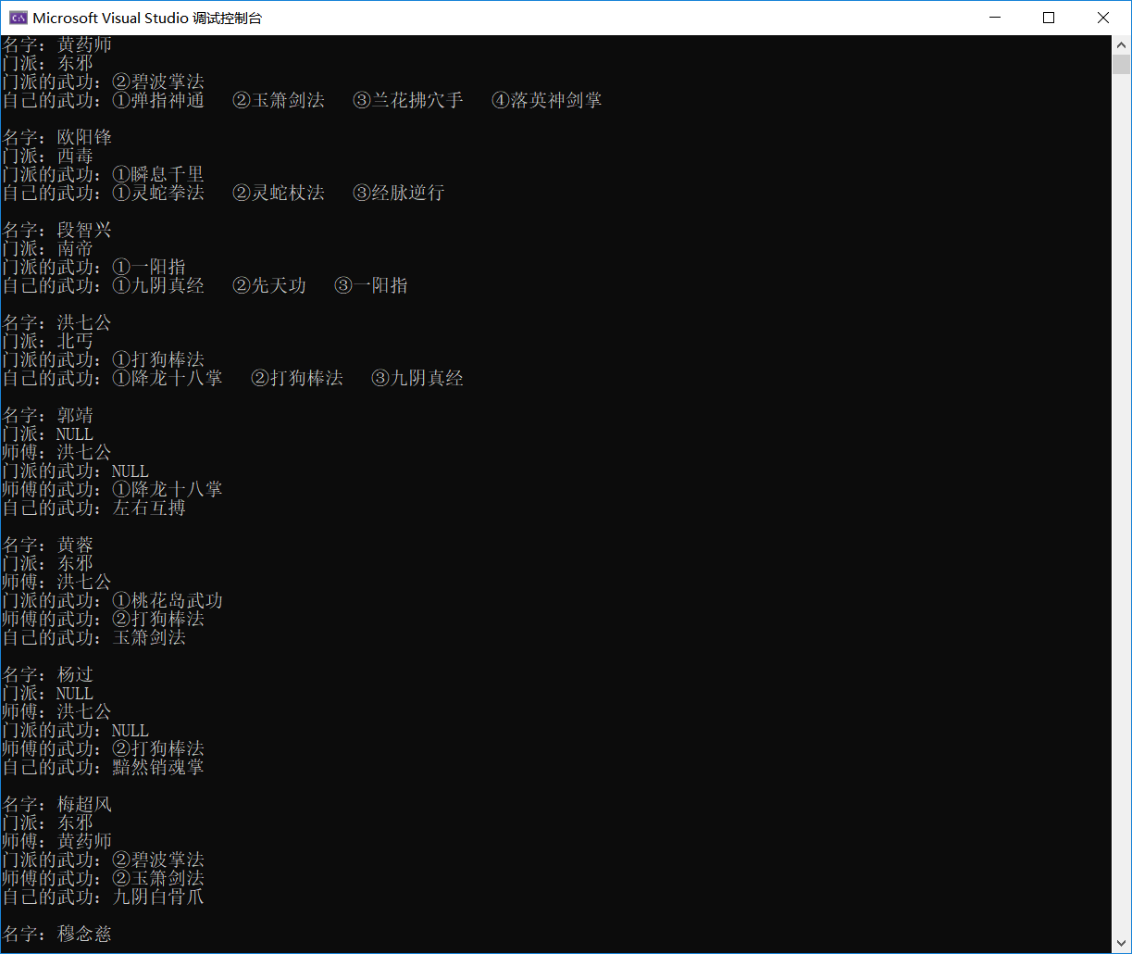实验截图

